ICIN Bank

Use Case

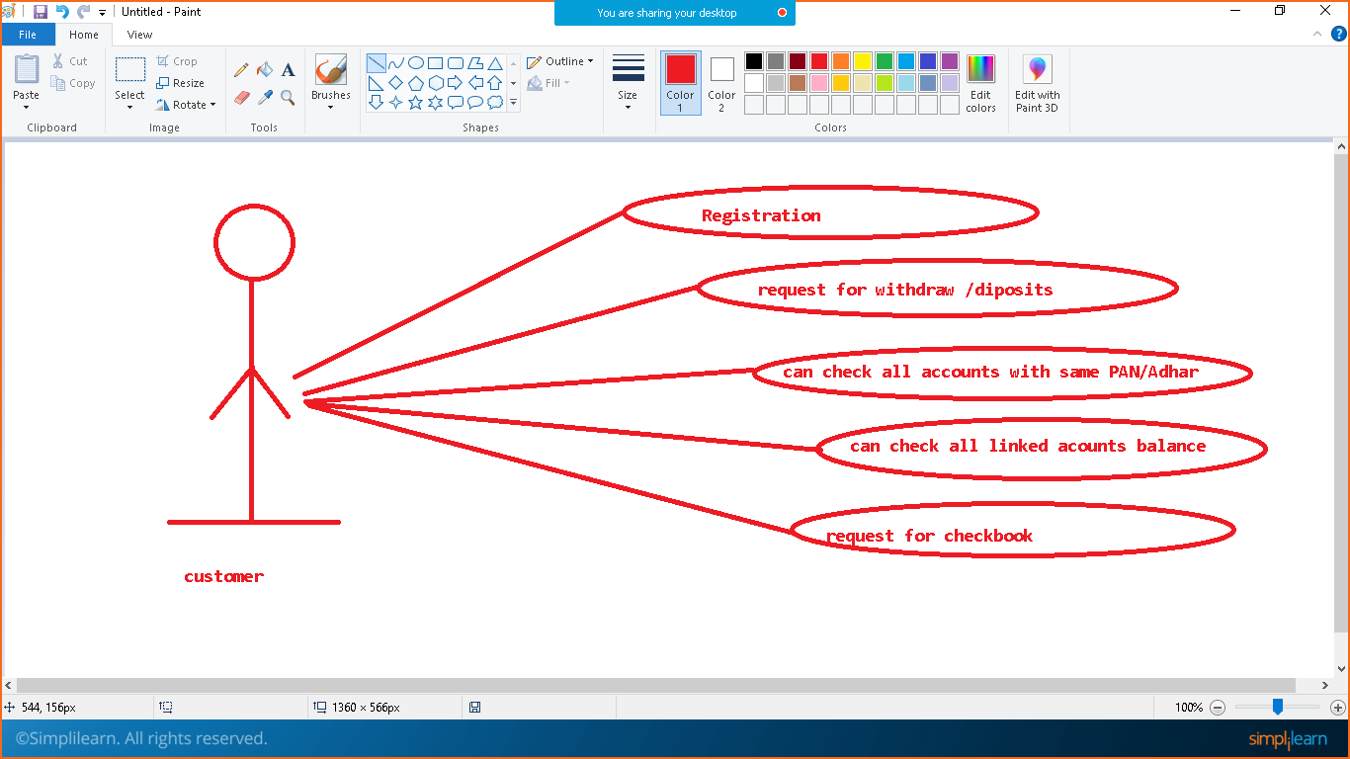

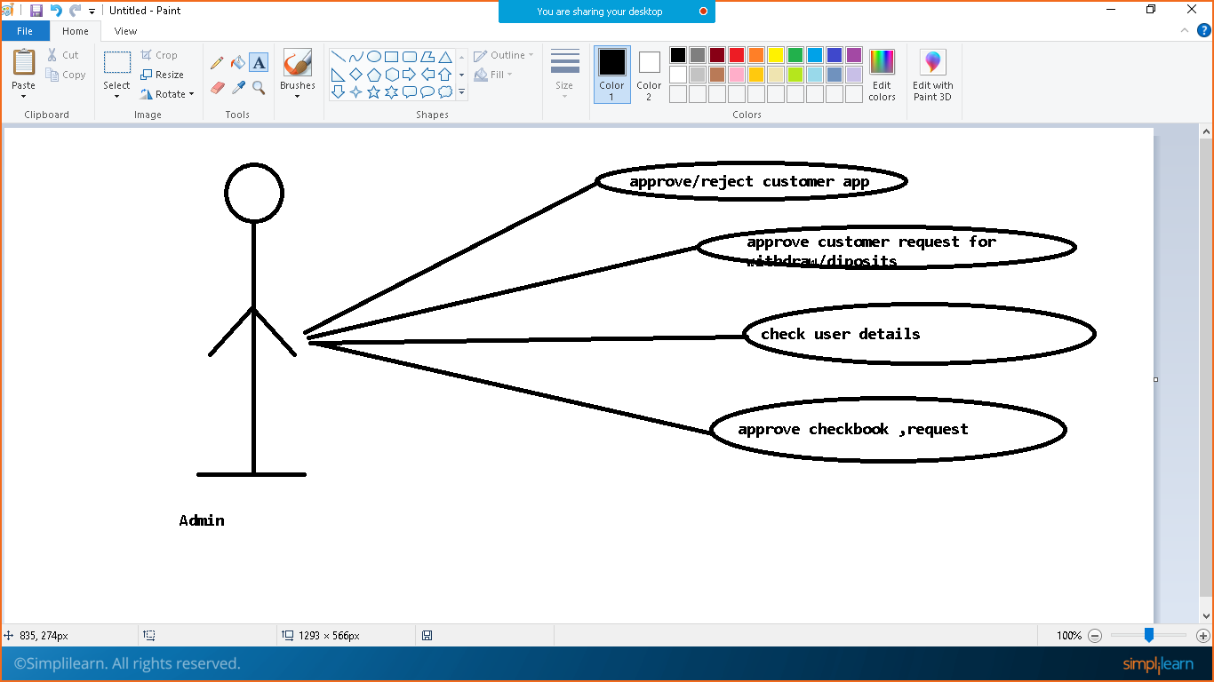

HomePage



Login Page

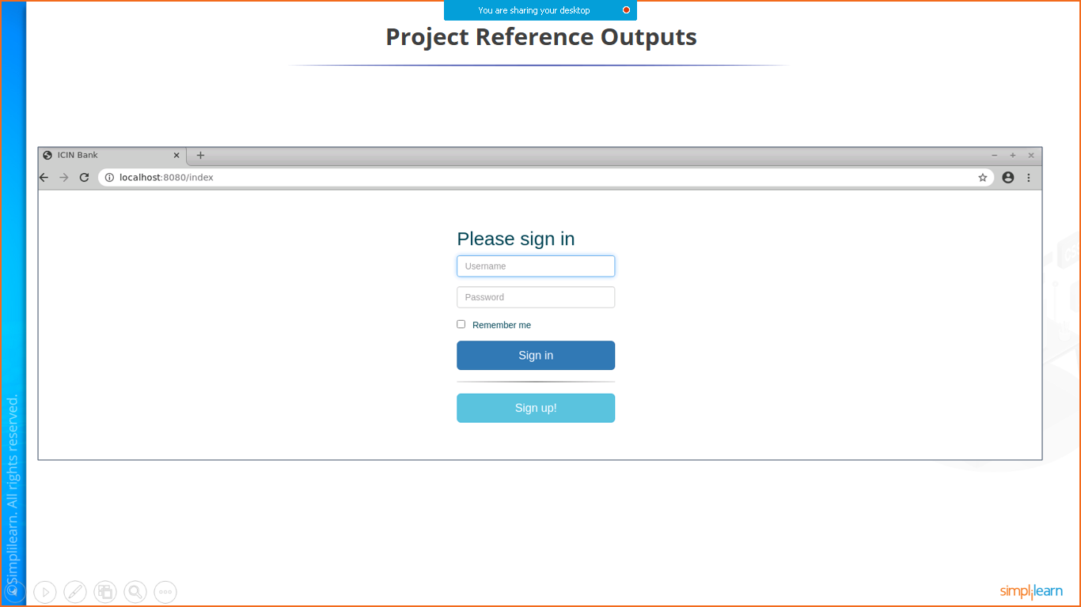

If wrong credentials

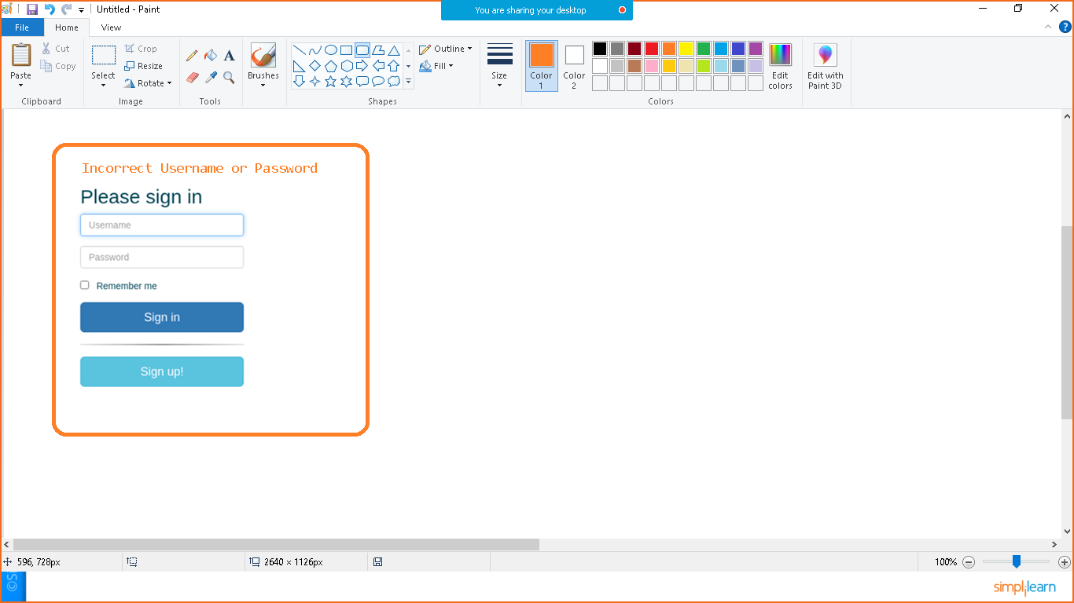

If Valid details entered

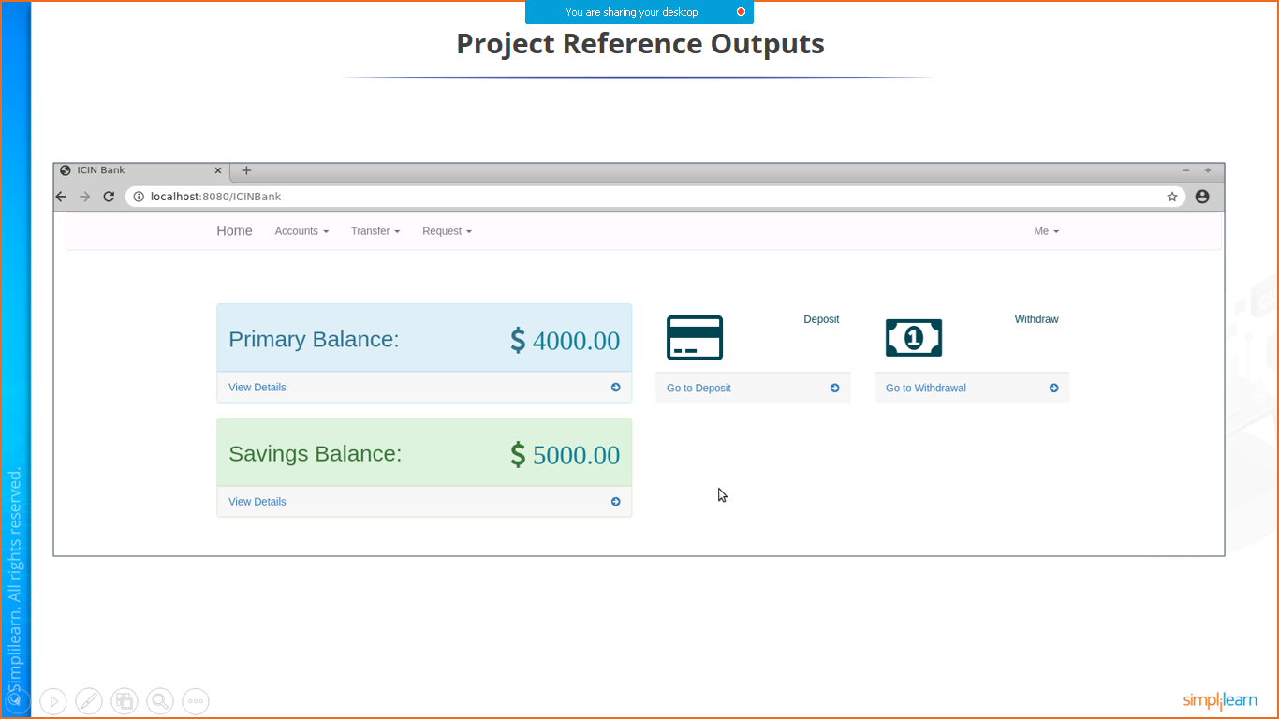

**Edit Profile**

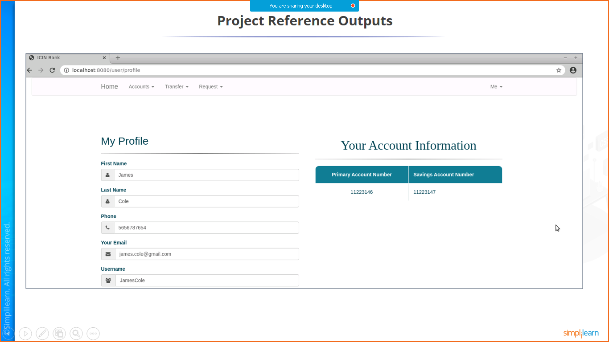

**User can request for the Cheque**

**Click on Request dropdown and select Check**

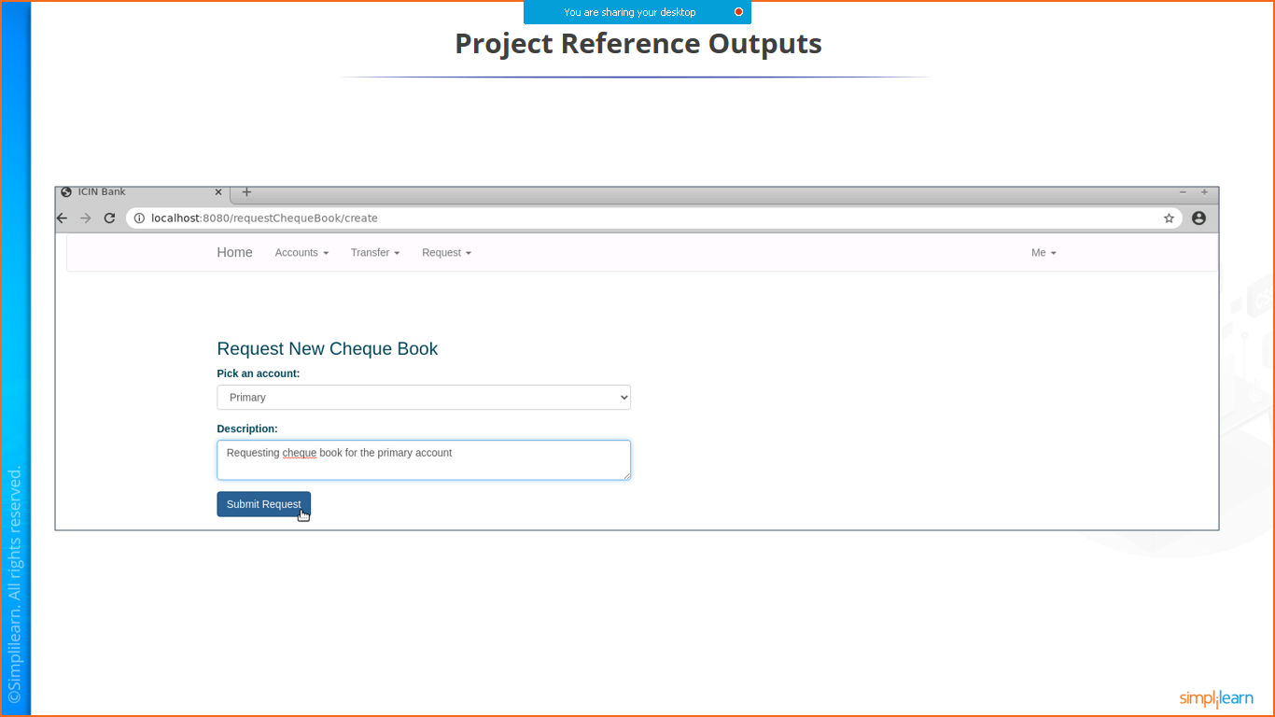

**Similarly you can do the transfer request**

1. **IMPS (instant Transfer) : (taking 5 Rs extra)**
2. **NEFT (Standard Pay)**

**Transfer you need to User Account Details**

**(acc No, Acc holder name, IFSC code, nick name)**

**ADD to the database**

**If user doesn’t has an account then Redirect to register Page**

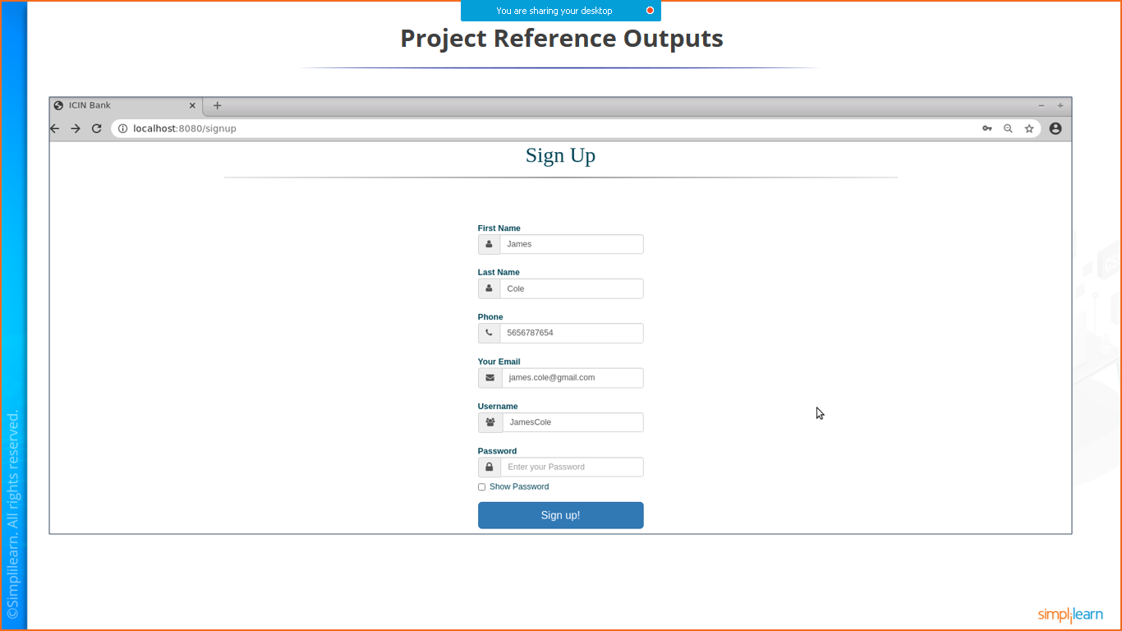

**After Registration done successful Redirect user to Login Page.**

**Admin Side**

**Admin login**

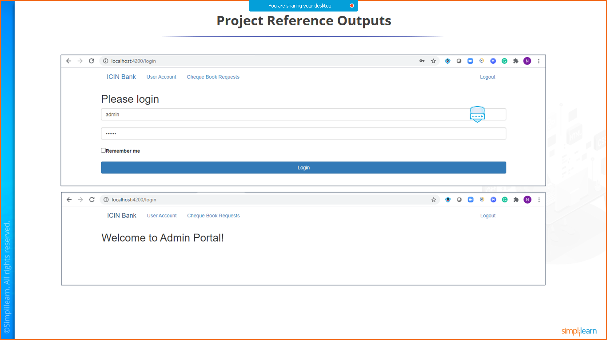

**If user click on UserAccount Link (show the registered User)**

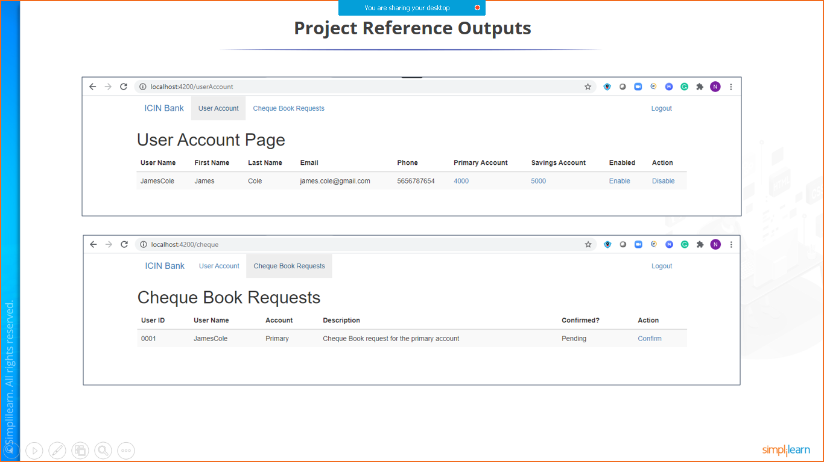

**If Admin founds the details are fake then he can delete user else, enable the account.**

**If admin select Checkbook request**

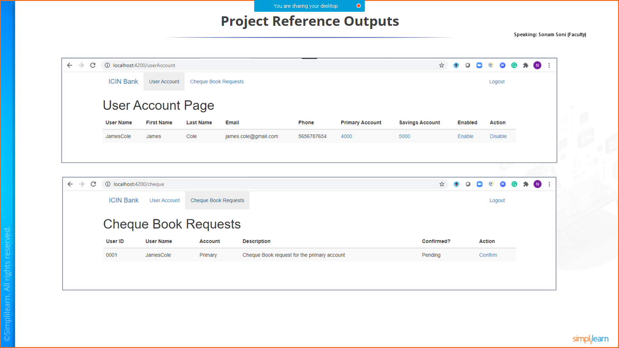

**If admin clicks on confirm the request approved.**

